Software Engineering
Assignment 2
Group Members :-
- Muhammad Ali Faraz (F2024065247)
- Muhammad Hasanat Khan (F2024065242)
Project Name: Carrefour System

1. List of Actors

Primary Actors
The main users who initiate interaction with the system.

- Administrator: Responsible for managing users, system settings, permissions, and generating reports.
- Store Manager: Responsible for managing inventory, checking stock levels, and receiving system alerts.
- Cashier: Responsible for processing sales transactions and printing receipts at the point of sale.
- Customer: Interacts with the system to view loyalty points and rewards.

Secondary / External Actors
Support roles and external systems connected to CIRMS.

- Database System: Stores and retrieves all operational data (inventory, users, sales logs).
- POS Hardware: The physical scanning and payment hardware used during transactions.
- Notification System: External service used to send alerts (e.g., email or SMS) for low stock or system warnings.

2. Use Case Specifications

Table 1: UC001 – Manage Users
Field | Description
Use Case ID | UC001
Use Case Name | Manage Users
Primary Actor | Administrator
Secondary Actors | Database System
Preconditions | – Administrator must be logged in. – System must be connected to the database.
Postconditions | – User is added/updated/removed successfully. – All changes are saved in the database.
Main Flow | 1. Administrator opens user management module. 2. System displays list of existing users. 3. Administrator selects “Add”, “Edit”, or “Delete” user. 4. Administrator enters or updates user details. 5. System validates entered information. 6. System saves updated user data into database. 7. System displays confirmation message.
Alternate Flows | – If data is incomplete → system shows error message. – If username already exists → system asks for different username.
Extensions | – System sends notification email for new account creation.
Special Requirements | – Must follow strict role-based security. – Password encryption required.

Table 2: UC002 – Configure System Settings
Field | Description
Use Case ID | UC002
Use Case Name | Configure System Settings
Primary Actor | Administrator
Secondary Actors | Database System
Preconditions | – Admin access required.
Postconditions | – Settings stored and applied system-wide.
Main Flow | 1. Admin opens settings panel. 2. System displays configuration options. 3. Admin modifies values. 4. System validates values. 5. System updates settings. 6. Confirmation is displayed.
Alternate Flows | – Invalid setting → system rejects update.
Special Requirements | – Settings update must not crash running modules.

Table 3: UC003 – Manage Inventory
Field | Description
Use Case ID | UC003
Use Case Name | Manage Inventory
Primary Actor | Store Manager
Secondary Actors | Database System
Preconditions | – Manager logged in. – Inventory module available.
Postconditions | – Product list updated in database.
Main Flow | 1. Manager selects “Inventory”. 2. System shows full product list. 3. Manager chooses add/edit/delete. 4. Manager enters product information. 5. System updates stock list. 6. Confirmation is shown.
Alternate Flows | – Duplicate product → system warns manager.
Special Requirements | – Real-time inventory syncing required.

Table 4: UC004 – Check Stock Levels
Field | Description
Use Case ID | UC004
Use Case Name | Check Stock Levels
Primary Actor | Store Manager
Secondary Actors | Database System
Preconditions | – Manager is logged in.
Postconditions | – Current stock data is displayed.
Main Flow | 1. Manager opens “Stock Levels”. 2. System fetches real-time stock from database. 3. System displays available quantities.
Alternate Flows | – Network failure → system loads cached data.

Table 5: UC005 – Receive Low Stock Alerts
Field | Description
Use Case ID | UC005
Use Case Name | Receive Low Stock Alerts
Primary Actor | Store Manager
Secondary Actors | Notification System
Preconditions | – System monitoring is active.
Postconditions | – Alert is delivered to Manager.
Main Flow | 1. System monitors quantity levels. 2. When stock < threshold → alert triggers. 3. Manager receives notification.
Alternate Flows | – If alert system offline → system logs warning.

Table 6: UC006 – Process Sales Transaction
Field | Description
Use Case ID | UC006
Use Case Name | Process Sales Transaction
Primary Actor | Cashier
Secondary Actors | POS Hardware, Database System
Preconditions | – Cashier is logged into POS. – POS Hardware is active.
Postconditions | – Sale is recorded. – Inventory is decremented.
Main Flow | 1. Cashier opens POS screen. 2. Cashier scans items. 3. System calculates bill. 4. Customer pays. 5. System records transaction.
Alternate Flows | – Item not found → cashier enters manually. – Payment failed → cashier retries.

Table 7: UC007 – Print Receipt
Field | Description
Use Case ID | UC007
Use Case Name | Print Receipt
Primary Actor | Cashier
Secondary Actors | POS Printer (Hardware)
Preconditions | – Payment must be successful (from UC006).
Postconditions | – Physical receipt provided to customer.
Main Flow | 1. After payment → cashier selects “Print Receipt”. 2. POS prints physical receipt. 3. System saves digital copy.

Table 8: UC008 – Manage Customer Profiles
Field | Description
Use Case ID | UC008
Use Case Name | Manage Customer Profiles
Primary Actor | Administrator
Preconditions | – Admin logged in.
Postconditions | – Customer data updated.
Main Flow | 1. Admin opens CRM module. 2. System shows customer data. 3. Admin edits/updates records. 4. System saves changes.

Table 9: UC009 – View Loyalty Points
Field | Description
Use Case ID | UC009
Use Case Name | View Loyalty Points
Primary Actor | Customer
Preconditions | – Customer is logged in to app/kiosk.
Postconditions | – Points balance displayed.
Main Flow | 1. Customer logs in. 2. System retrieves loyalty points. 3. Customer views rewards.

Table 10: UC010 – Generate Reports
Field | Description
Use Case ID | UC010
Use Case Name | Generate Reports
Primary Actor | Administrator
Secondary Actors | Database System
Preconditions | – Admin is logged in.
Postconditions | – Report is generated.
Main Flow | 1. Admin selects “Reports”. 2. Chooses report type. 3. System generates report. 4. Admin downloads or views it.

Table 11: UC011 – View Real-time Dashboard
Field | Description
Use Case ID | UC011
Use Case Name | View Real-time Dashboard
Primary Actor | Administrator
Preconditions | – Admin is logged in.
Postconditions | – Dashboard displayed.
Main Flow | 1. Admin opens dashboard. 2. System displays live charts. 3. Data auto-refreshes.

Table 12: UC012 – Manage Permissions
Field | Description
Use Case ID | UC012
Use Case Name | Manage Permissions
Primary Actor | Administrator
Preconditions | – Admin has root privileges.
Postconditions | – User rights updated.
Main Flow | 1. Admin opens user permissions panel. 2. System loads permission matrix. 3. Admin modifies rights. 4. System saves changes.

Table – UC013: Redeem Loyalty Points
Field | Description
Use Case ID | UC013
Use Case Name | Redeem Loyalty Points
Primary Actor | Customer (via Cashier)
Secondary Actors | Database System
Preconditions | – Customer must have a loyalty account.– Customer must have sufficient points.– Cashier must be logged in to POS.
Postconditions | – Points are deducted.– Discount applied to bill.– Updated points saved in database.
Main Flow | 1. Customer requests to redeem points.2. Cashier selects “Redeem Points.”3. System retrieves available points.4. System calculates eligible discount.5. Cashier confirms redemption.6. System applies discount.7. Customer completes payment.
Alternate Flows | – If points are insufficient → system notifies cashier.– If database error → redemption unavailable; checkout continues normally.
Special Requirements | – Redemption rules must be configurable in system settings.

Table – UC014: Customer Segmentation
Field | Description
Use Case ID | UC014
Use Case Name | Customer Segmentation for Promotions
Primary Actor | Administrator / Manager
Secondary Actors | Database System
Preconditions | – Admin/Manager is logged in.– CRM data is available.
Postconditions | – Customers are grouped into segments.– Segmentation results stored for promotions.
Main Flow | 1. Admin/Manager opens segmentation module.2. System shows segmentation criteria.3. User selects desired criteria.4. System analyzes CRM data.5. Segmented groups displayed.6. User saves segmentation.
Alternate Flows | – No customers match criteria → system shows “No results.”– Invalid criteria → system warns and asks for adjustment.
Special Requirements | – Must handle large datasets efficiently.

Table – UC015: Customer Login
Field | Description
Use Case ID | UC015
Use Case Name | Customer Login
Primary Actor | Customer
Secondary Actors | Database System
Preconditions | – Customer is registered.– System is connected to database.
Postconditions | – Customer is authenticated and granted access to loyalty account.
Main Flow | 1. Customer opens login page (app/kiosk/web).2. Customer enters username and password.3. System validates credentials.4. Customer is logged in and redirected to account dashboard.
Alternate Flows | – Invalid password → system shows error.– Account not found → customer prompted to retry or register.
Special Requirements | – Password encryption required.– Login timeout for security.

Table – UC016: View Loyalty Points, Rewards, Profile
Field | Description
Use Case ID | UC016
Use Case Name | View Loyalty Account Information
Primary Actor | Customer
Secondary Actors | Database System
Preconditions | – Customer is logged in (UC015).
Postconditions | – Loyalty points, rewards, and profile information are displayed.
Main Flow | 1. Customer opens “My Loyalty Account.”2. System retrieves loyalty points.3. System displays available rewards.4. System displays customer profile details.
Alternate Flows | – Database unavailable → system shows temporary error.– Customer profile incomplete → system requests missing info.
Special Requirements | – Must update in real-time after transactions.

3. List of Use Cases

Write all major functionalities the system provides
• UC001 – Manage Users
Actor: Admin
Allows administrators to add, update, and remove users from the system.
• UC002 – Configure System Settings
Actor: Admin
Allows administrators to access and configure system-wide settings.
• UC003 – Manage Inventory
Actor: Manager
Enables store managers to add, edit, and delete inventory items.
• UC004 – Check Stock Levels
Actor: Manager
Allows managers to view real-time stock levels across all branches.
• UC005 – Receive Low Stock Alerts
Actor: Manager
Automatically notifies managers when stock falls below the minimum threshold.
• UC006 – Process Sales Transaction
Actor: Cashier
Allows cashiers to scan products and complete sales at the POS.
• UC007 – Print Receipt
Actor: Cashier
Enables cashiers to generate digital or physical receipts for each transaction.
• UC008 – Manage Customer Profiles
Actor: Admin, Manager
Maintains customer information, purchase history, and CRM data.
• UC009 – View Loyalty Points
Actor: Customer
Allows customers to view their loyalty points and rewards in their accounts.
• UC010 – Generate Reports
Actor: Admin, Manager
Produces reports for sales, inventory, and customer analytics.
• UC011 – View Real-time Dashboard
Actor: Admin, Manager
Displays live performance statistics and visual analytics for managers and admins.
• UC012 – Manage Permissions
Actor: Admin
Enables administrators to set user roles and access levels to ensure proper security.
• UC013 – Redeem Loyalty Points
Actor: Customer (via Cashier)
Allows customers to redeem their loyalty points at checkout to receive eligible discounts and reduce their total bill.
•
UC014 – Customer Segmentation for Promotions
Actor: Administrator, Manager
Enables the system to group customers into segments based on CRM data for targeted promotions and personalized marketing campaigns.

• UC015 – Customer Login
Actor: Customer
Allows customers to securely log in to their loyalty accounts to access their points, rewards, and personal information.

• UC016 – View Loyalty Points, Rewards & Profile
Actor: Customer
Allows customers to view their loyalty points, available rewards, and personal profile details within their account dashboard.

4. Complete Use Case Diagram

System Boundary  Admin Manager Cahier Customer System Boundary 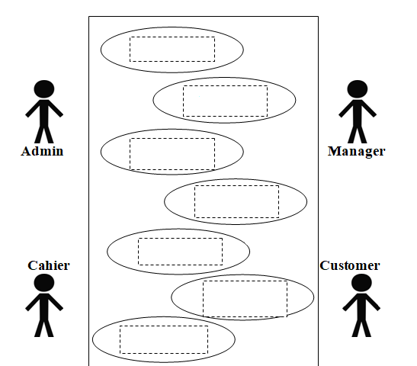 UML CLASS DIAGRAM 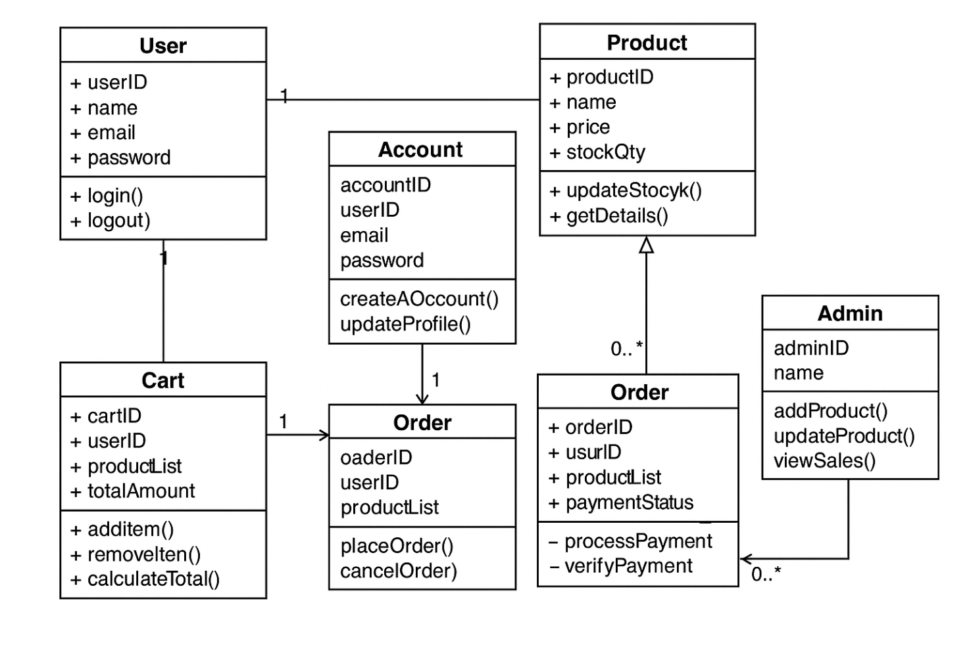
Process Sales Transaction
Receive Low Stock Alerts
Check Stock Levels
Manage Inventory
Configure System Setting
Print Receipt
Manage Users
Customer Segmentation for Promotions
Redeem Loyalty Points
Manage Permission
View Real-time Dashboard
Generate Reports
View Loyalty Points
Manage Customer Profiles
Customer Login
View Loyalty Points, Rewards & Profile

